Day22 - Task10 - AWS VPC Transit Gateway & VPC Endpoint

Create one VPC, with 1 public subnet and 1 private subnet.
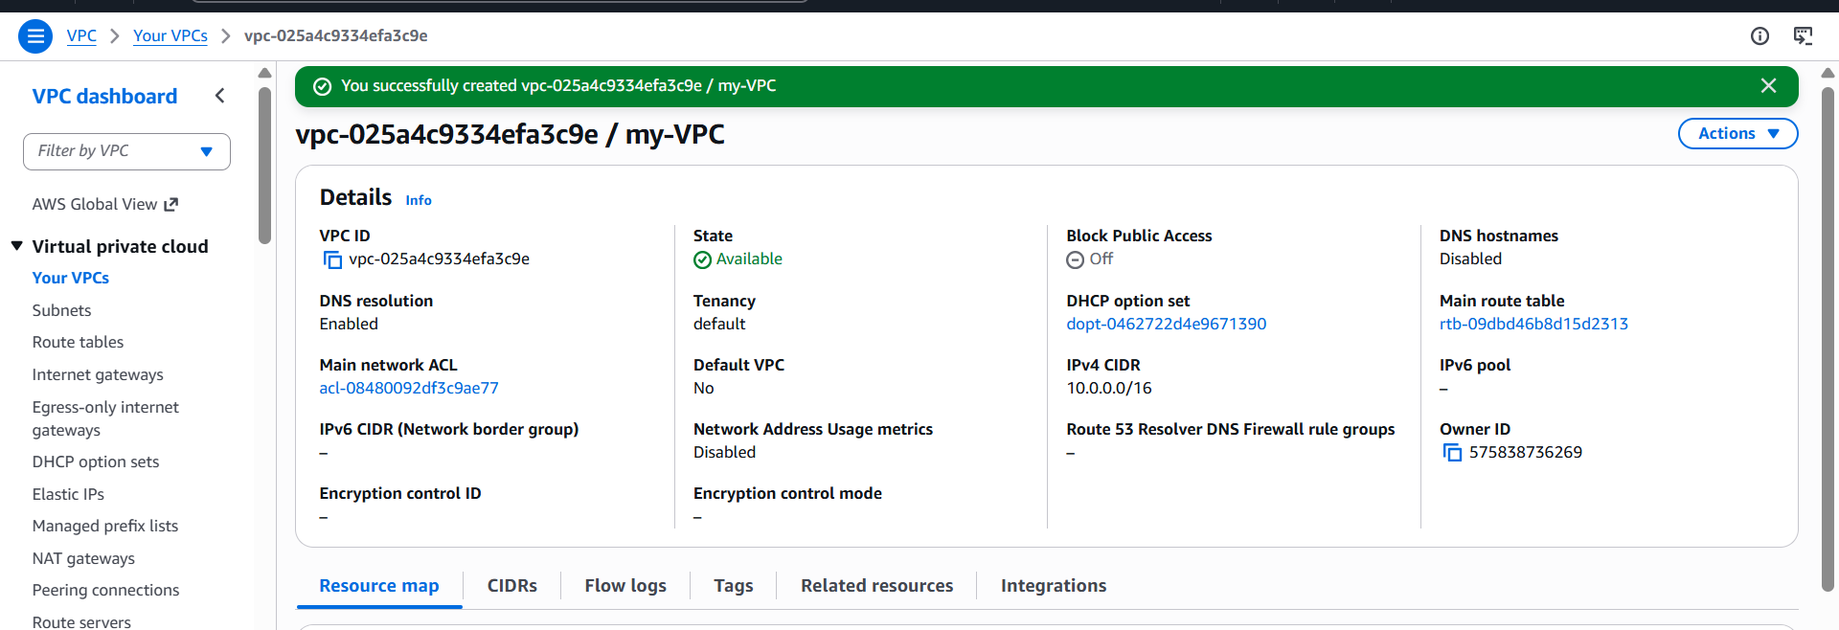
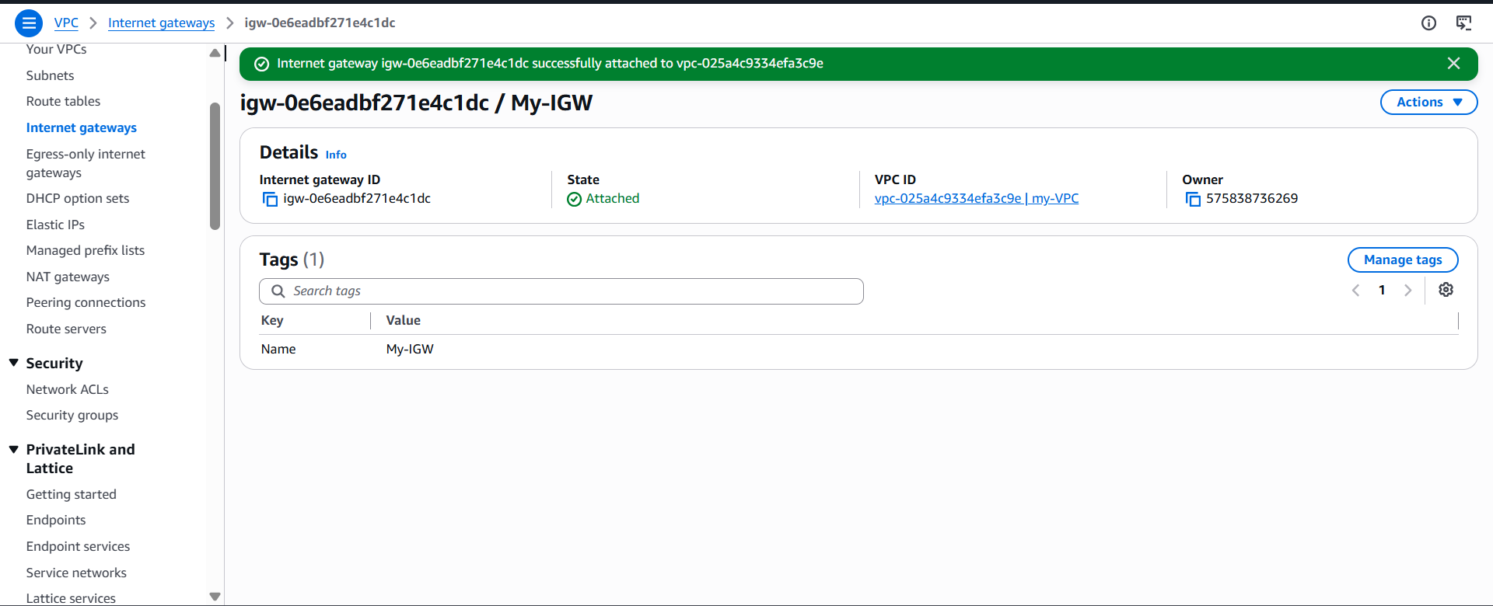
Enable VPC peering for cross-region.
Two VPCs in different AWS Regions
Example:
- my-VPC → Europe (Stockholm) (eu-north-1)
- VPC-C → Asia Pacific (Mumbai) (ap-south-1)
Create a VPC in Another Region
- Log in to the AWS Console.
- Change the region to Asia Pacific (Mumbai) (ap-south-1).
- Open VPC.
- Click Create VPC.
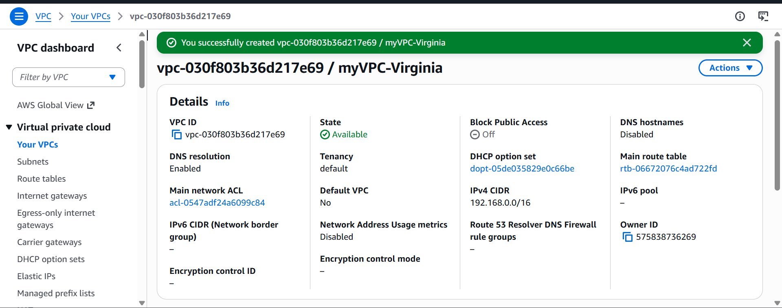
Create a VPC Peering Connection
- Switch to the Europe (Stockholm) region.
- Open VPC.
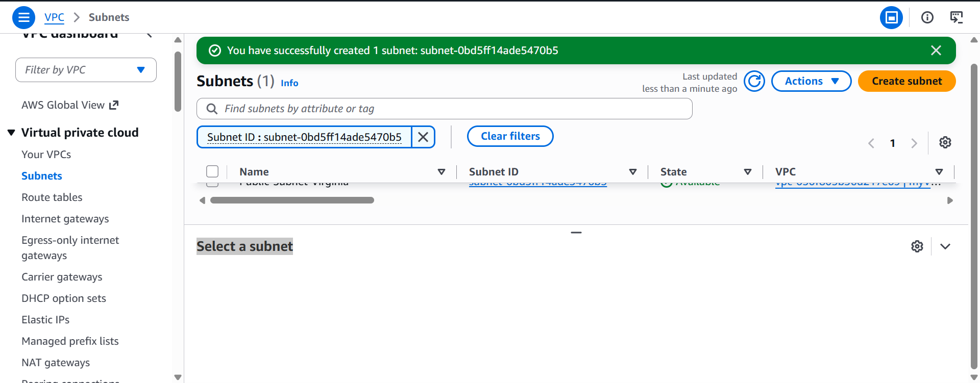
Enter Peering Details
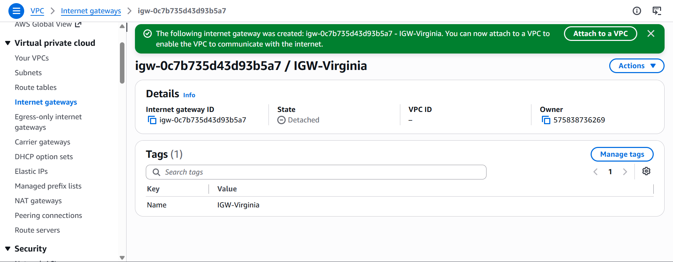
Update Route Table in my-VPC
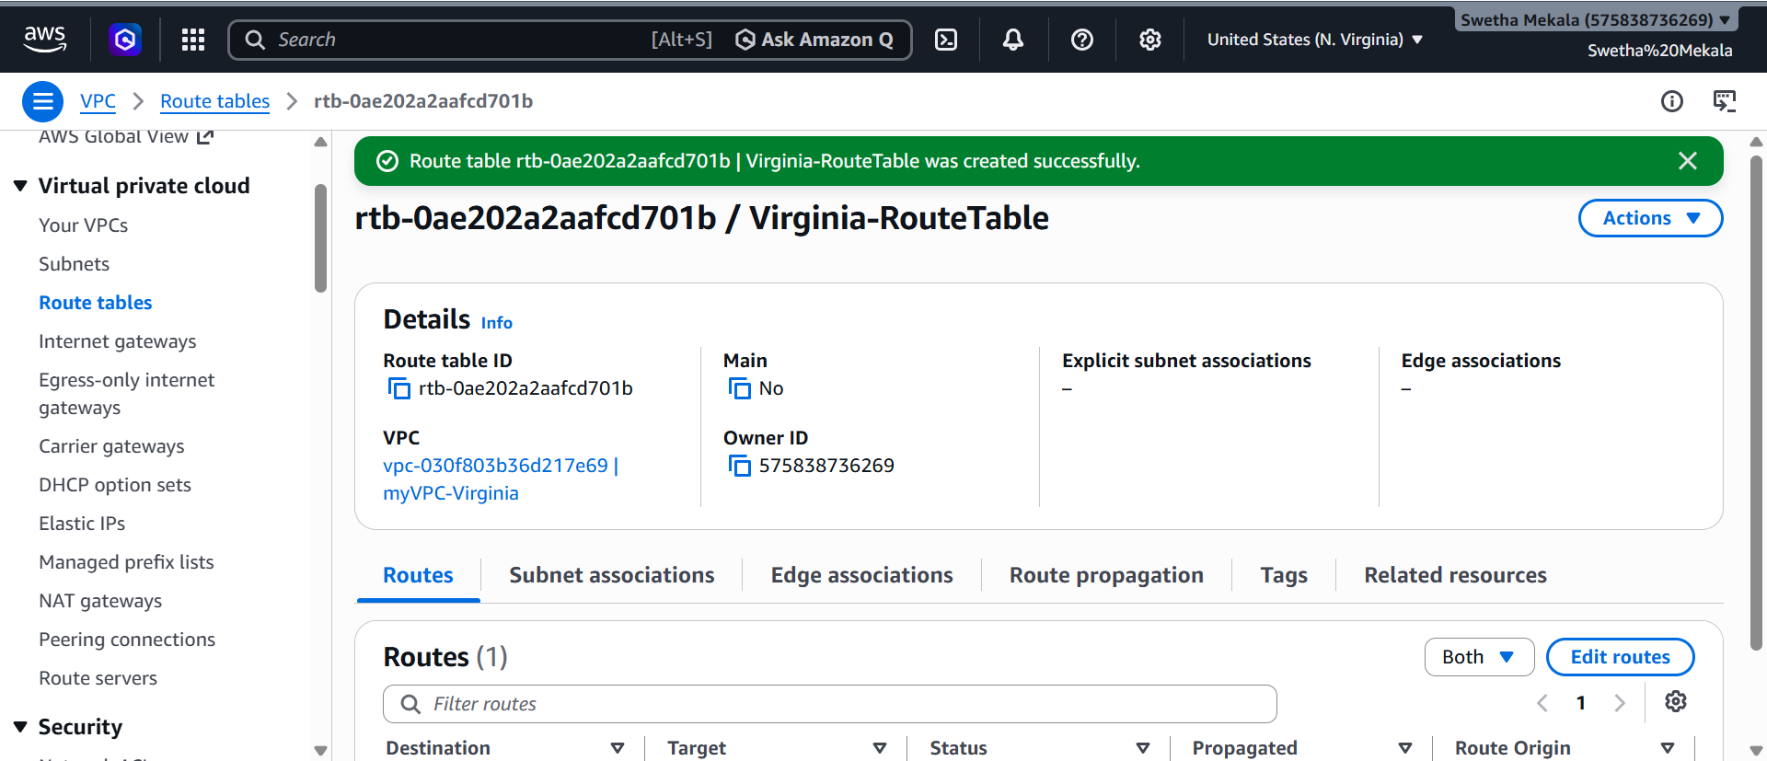
Update Security Groups
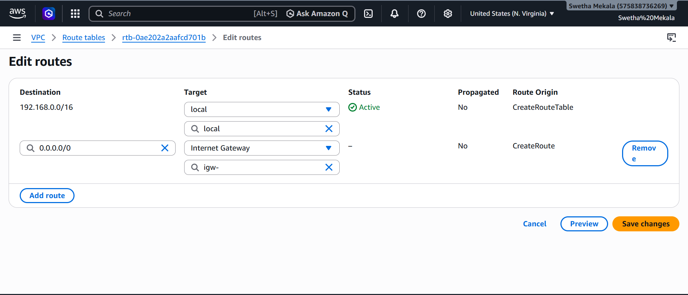
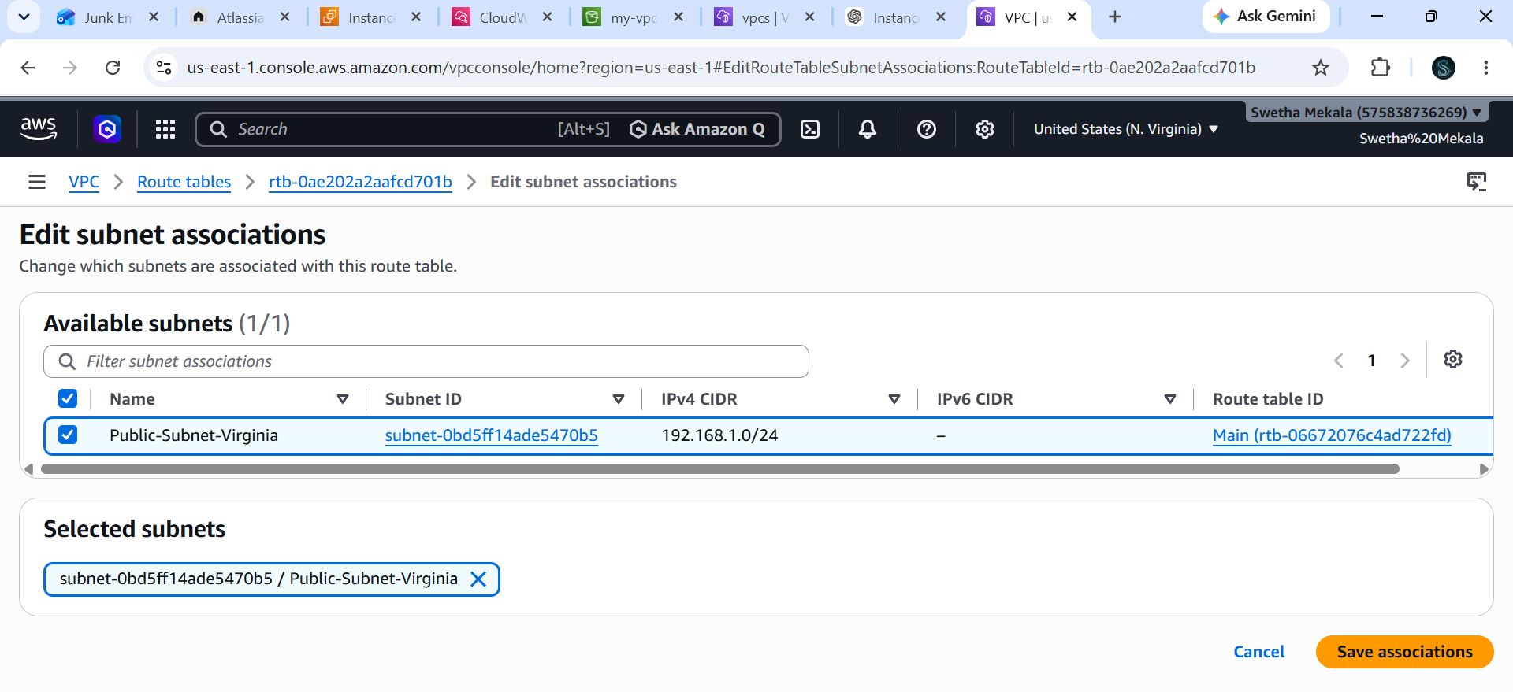Launch EC2 Instances
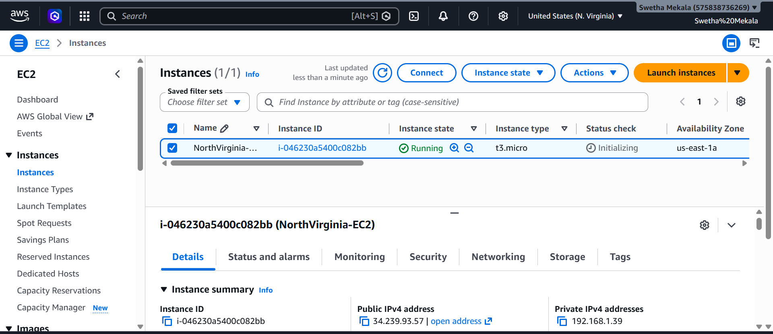
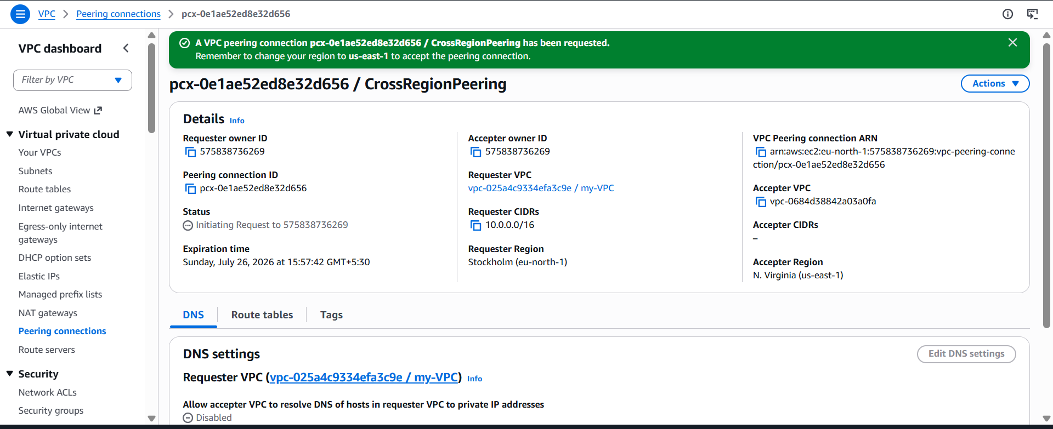
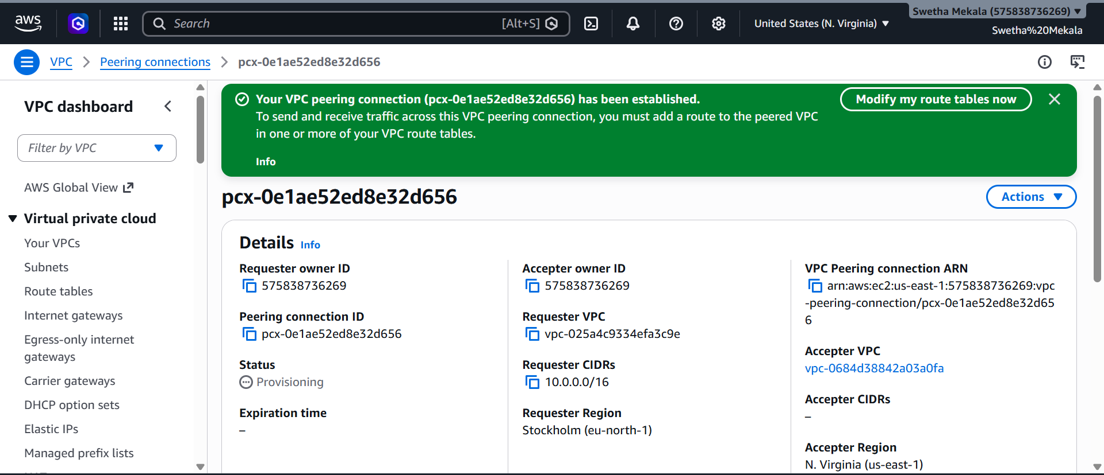
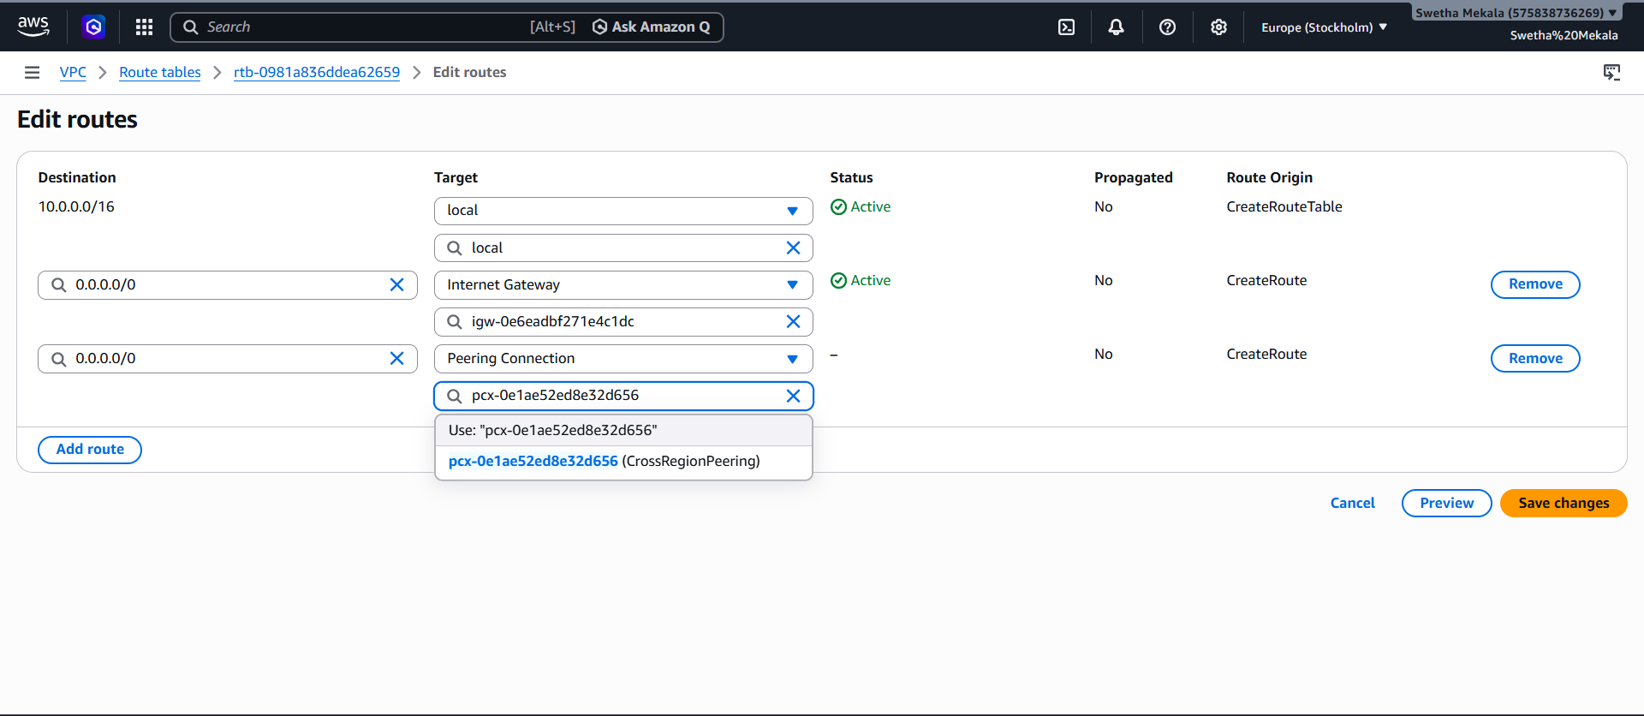
Enable VPC peering for cross-account (you can collaborate with your friend to do this task).
You and your friend should have:
- Two different AWS accounts.
- One VPC in each account.
- VPCs must have different CIDR blocks.
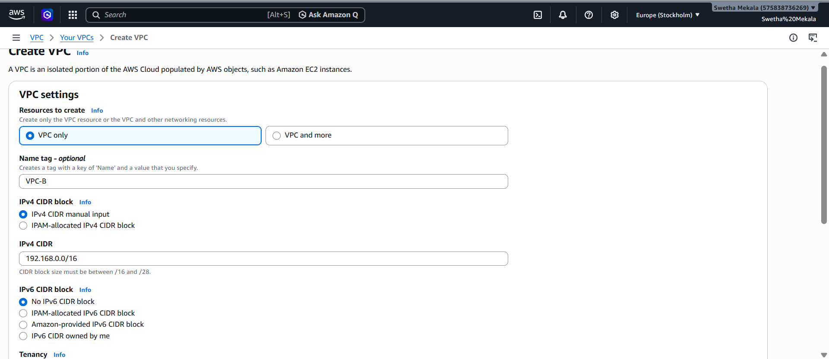

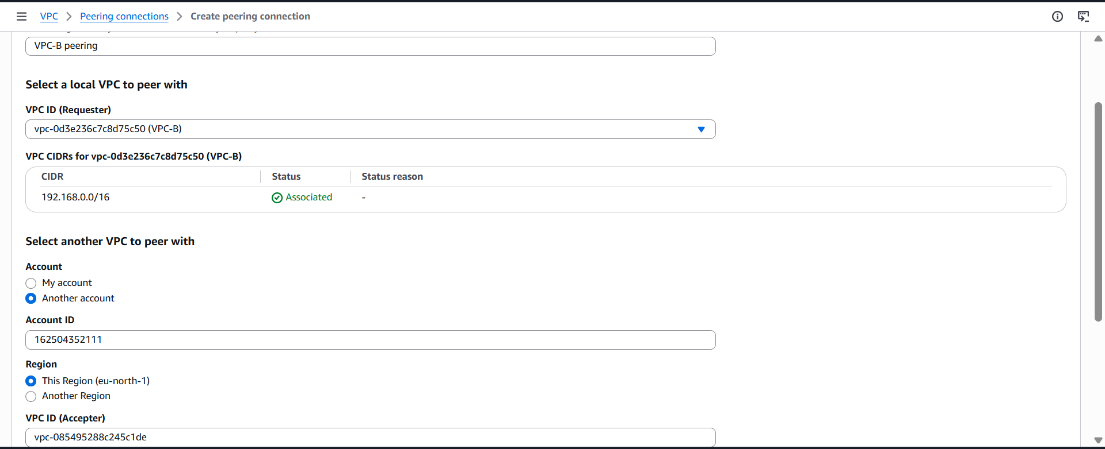

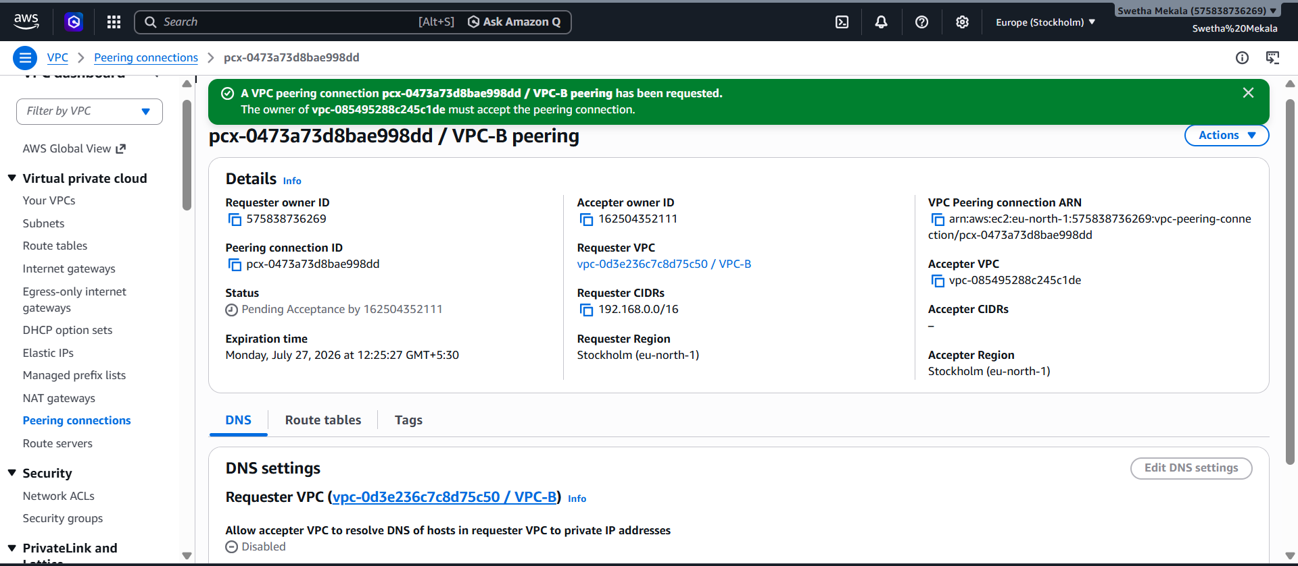
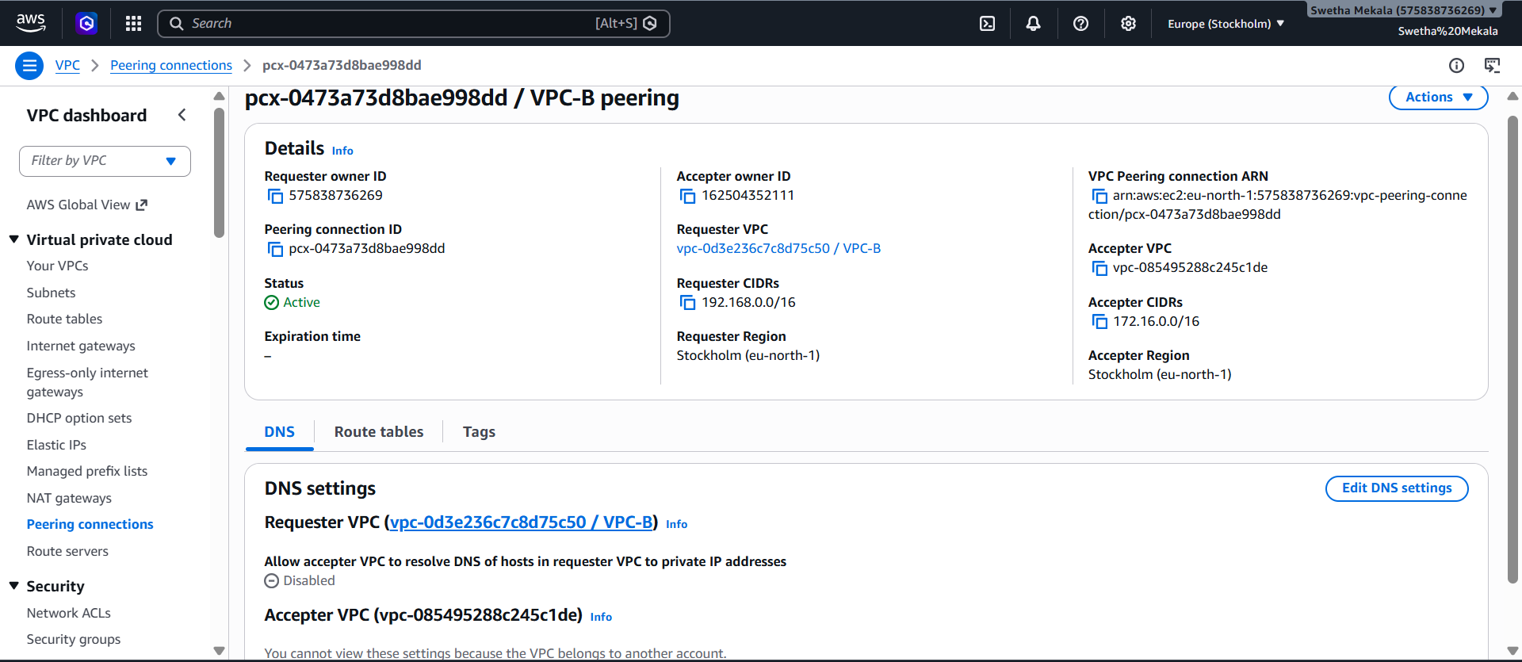
Ask your friend for:
- AWS Account ID
- VPC ID
- Region
- VPC CIDR block
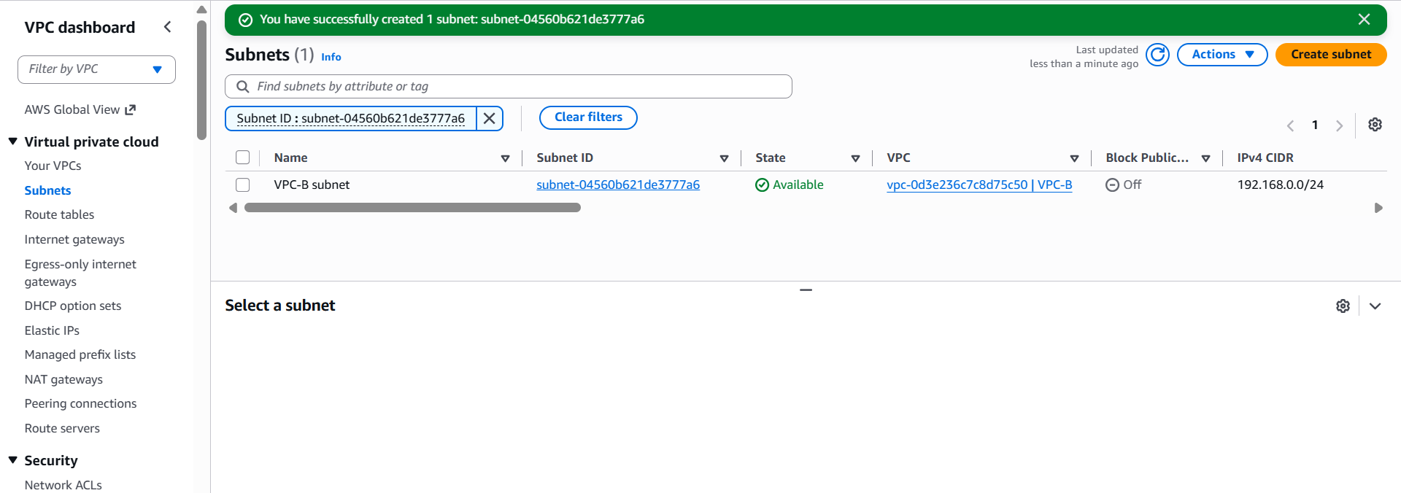
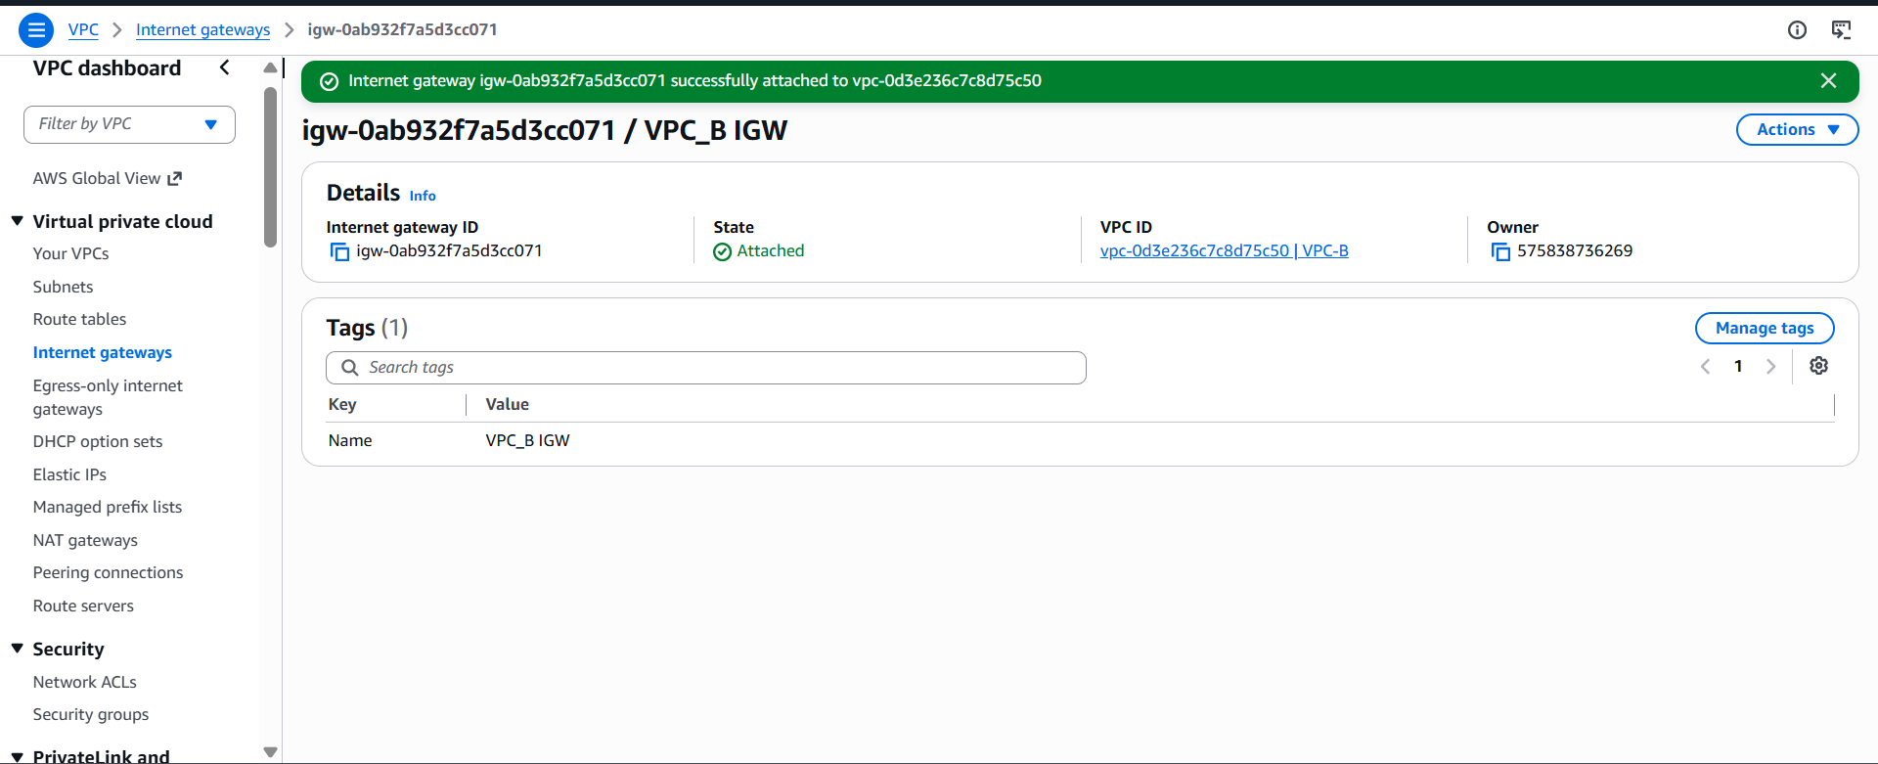
Friend Accepts the Request
Your friend should:
- Sign in to their AWS account.
Update Your Route Table
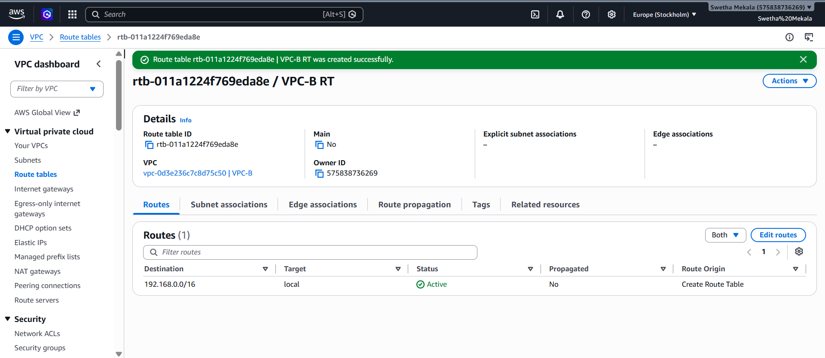
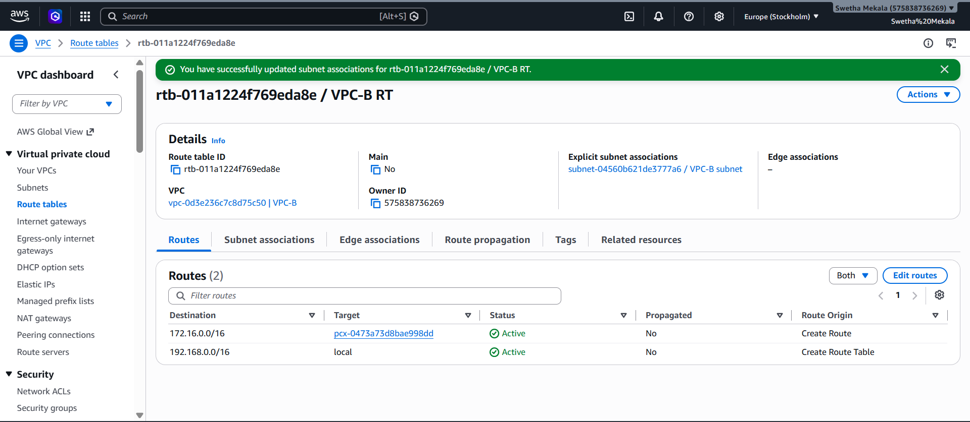Creating instance
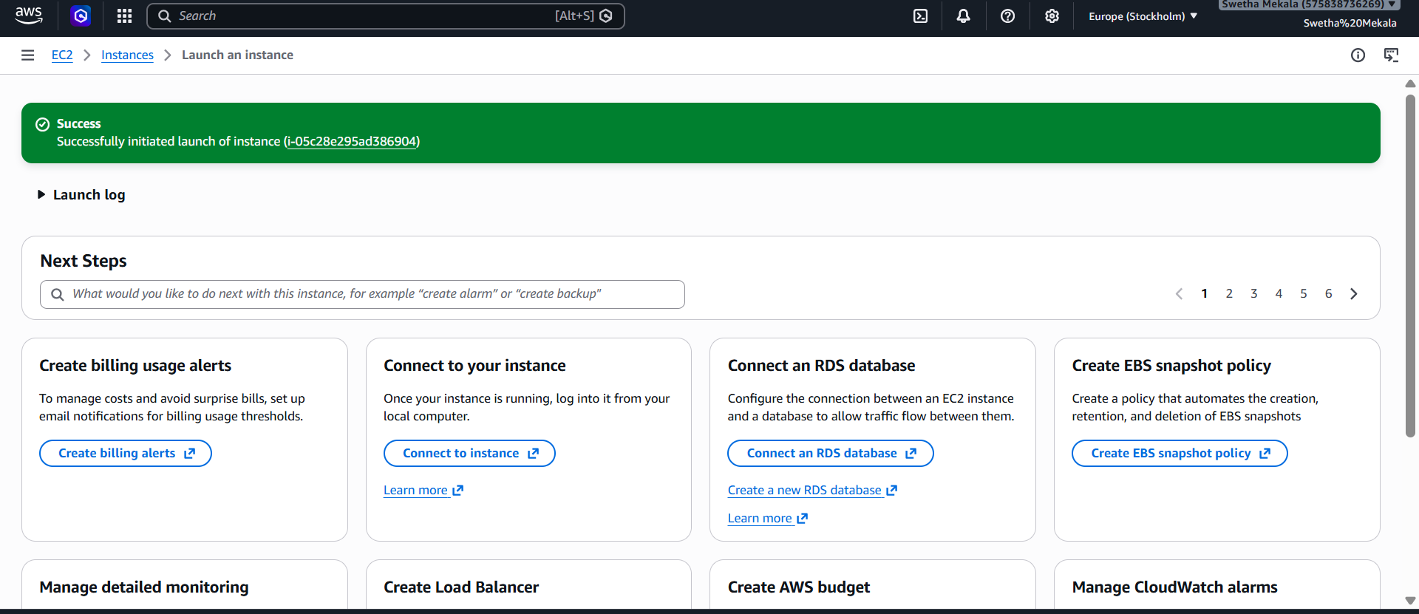
On your EC2 Security Group (VPC-B)
Add an inbound rule like this:
Type | Source
All ICMP - IPv4 | 172.16.0.0/16
If you also want your friend to SSH to your EC2:
Type | Port | Source
SSH | 22 | 172.16.0.0/16

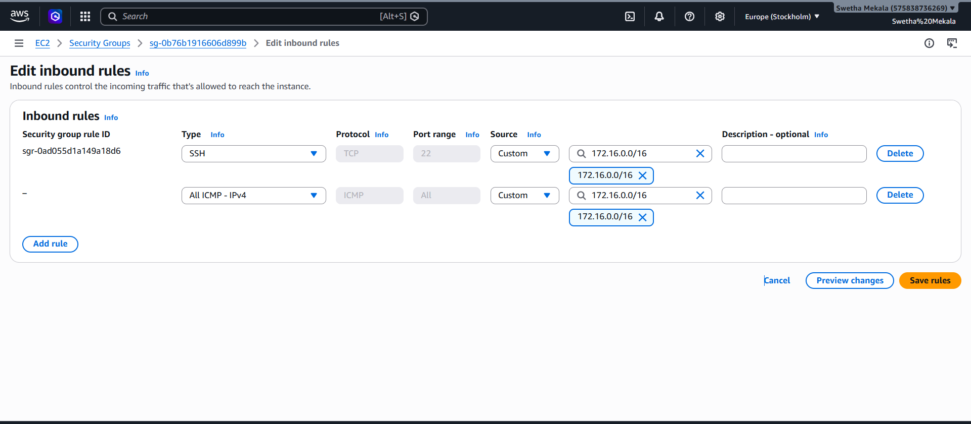
Verified the connectivity
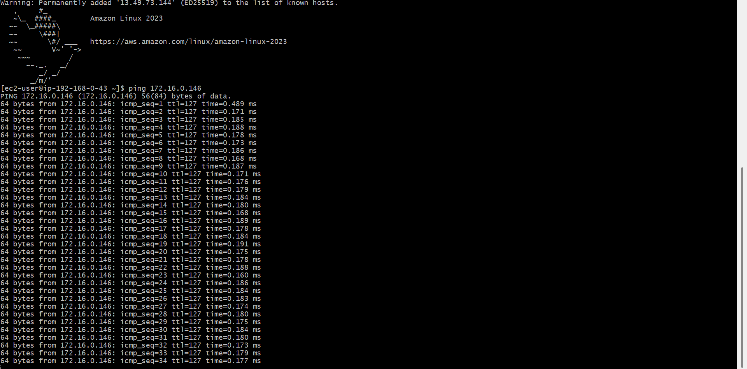
Set up a VPC Transit Gateway.
Verify Your VPCs
Open the AWS Console.
Select the Europe (Stockholm) region.
Go to VPC Dashboard → Your VPCs.
Confirm that Default VPC, myVpc, and VPC-B are listed in this region.
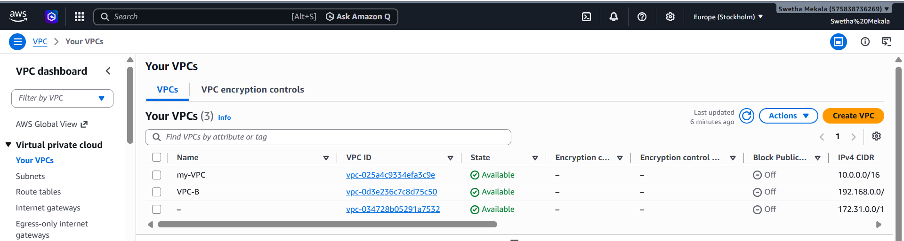
Create a Transit Gateway
- Open VPC Dashboard.
- In the left menu, click Transit Gateways.
- Click Create Transit Gateway.
Enter:
- Name tag: TGW-Stockholm
- Description: Transit Gateway for Lab (optional)
Leave the remaining settings at their default values unless your lab specifies otherwise.
Click Create Transit Gateway.
Wait until the state changes to Available.
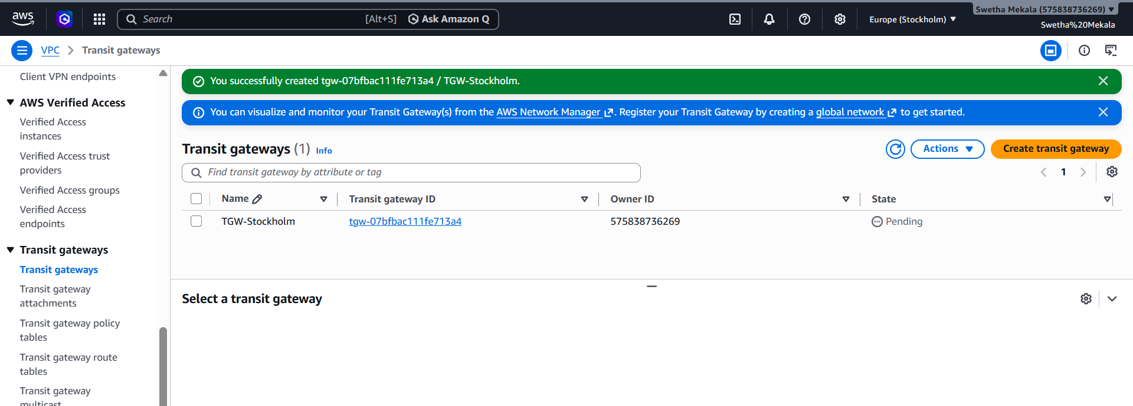
Open Transit Gateway Attachments
- Go to VPC Dashboard.
- In the left menu, click Transit Gateway Attachments.
- Click Create transit gateway attachment.
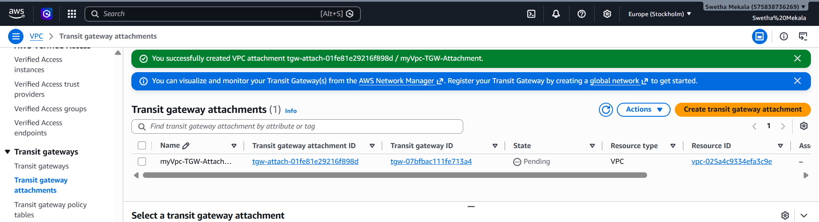

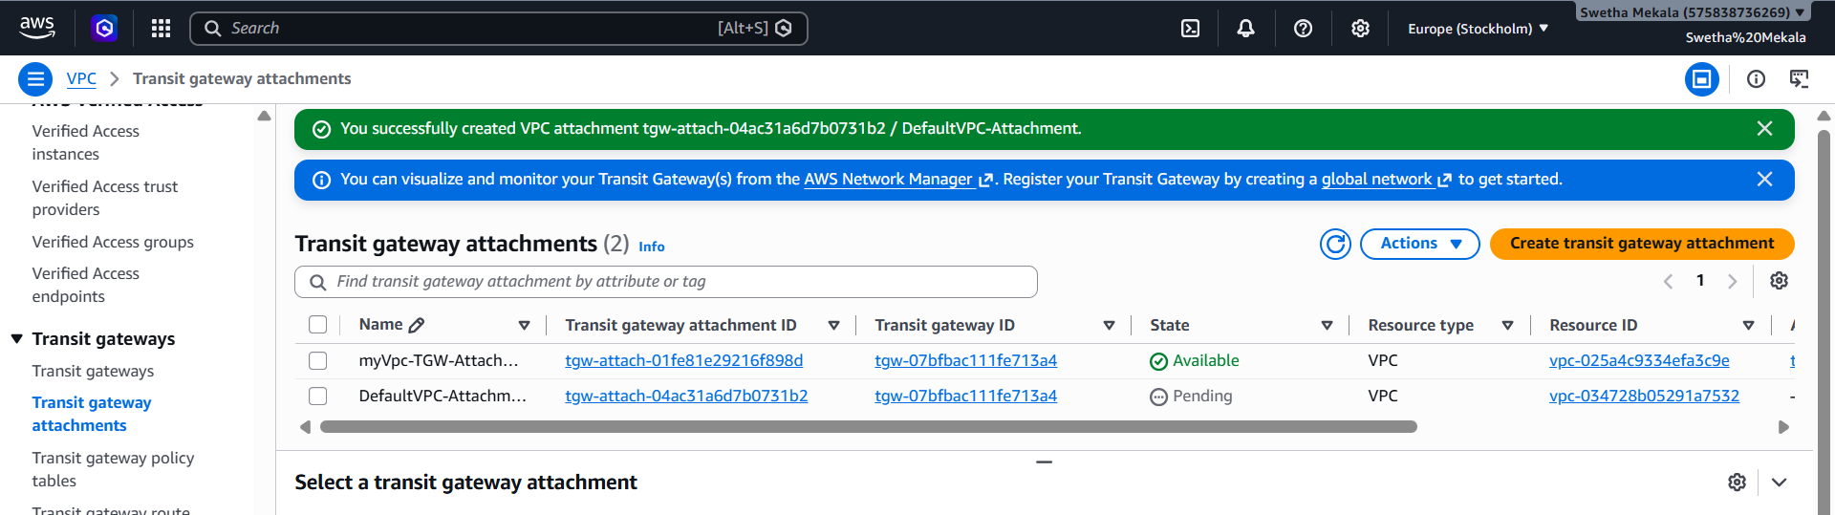

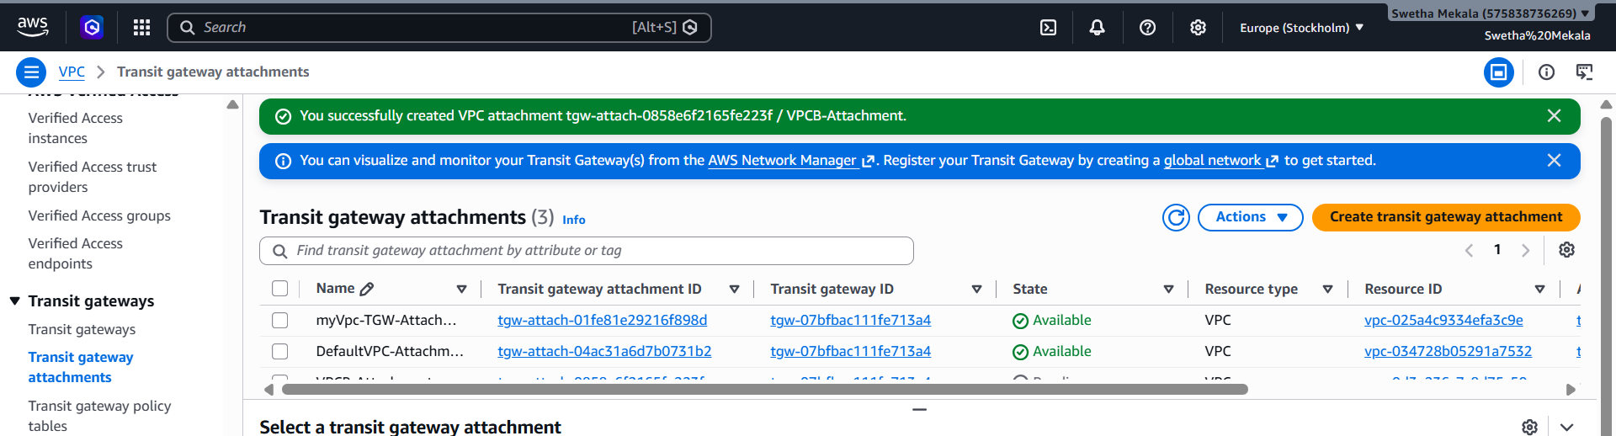
Verify the Attachments
After you're done, go to Transit Gateway Attachments.
You should see something like:
Attachment Name | VPC | Status
myVpc-Attachment | myVpc | Available
DefaultVPC-Attachment | Default VPC | Available
VPCB-Attachment | VPC-B | Available
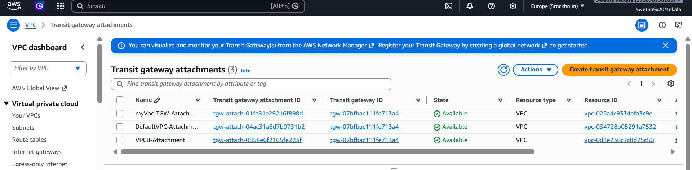
Route Table for myVpc
Keep these existing routes:
- ✅ 10.0.0.0/16 → Local
- ✅ 0.0.0.0/0 → Internet Gateway
Add these new routes:
Destination | Target
192.168.0.0/16 | Transit Gateway (tgw-...)
172.31.0.0/16 | Transit Gateway (tgw-...)
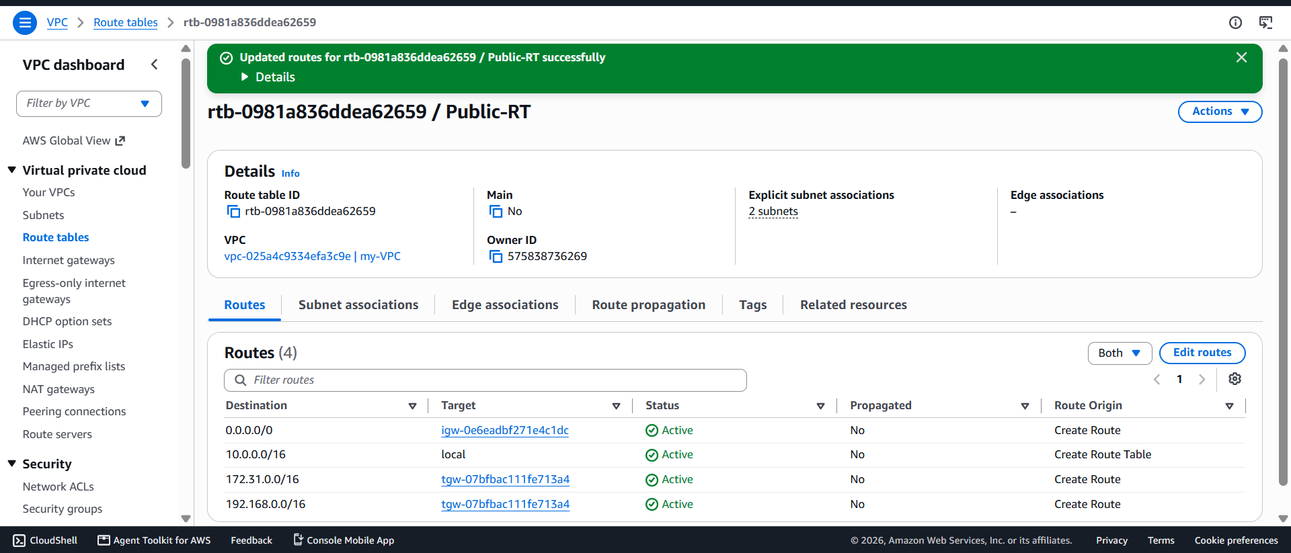
Route Table for VPC-B
Keep:
- ✅ 192.168.0.0/16 → Local
If VPC-B has an Internet Gateway and you want internet access, also keep:
- ✅ 0.0.0.0/0 → Internet Gateway
Add:
Destination | Target
10.0.0.0/16 | Transit Gateway
172.31.0.0/16 | Transit Gateway

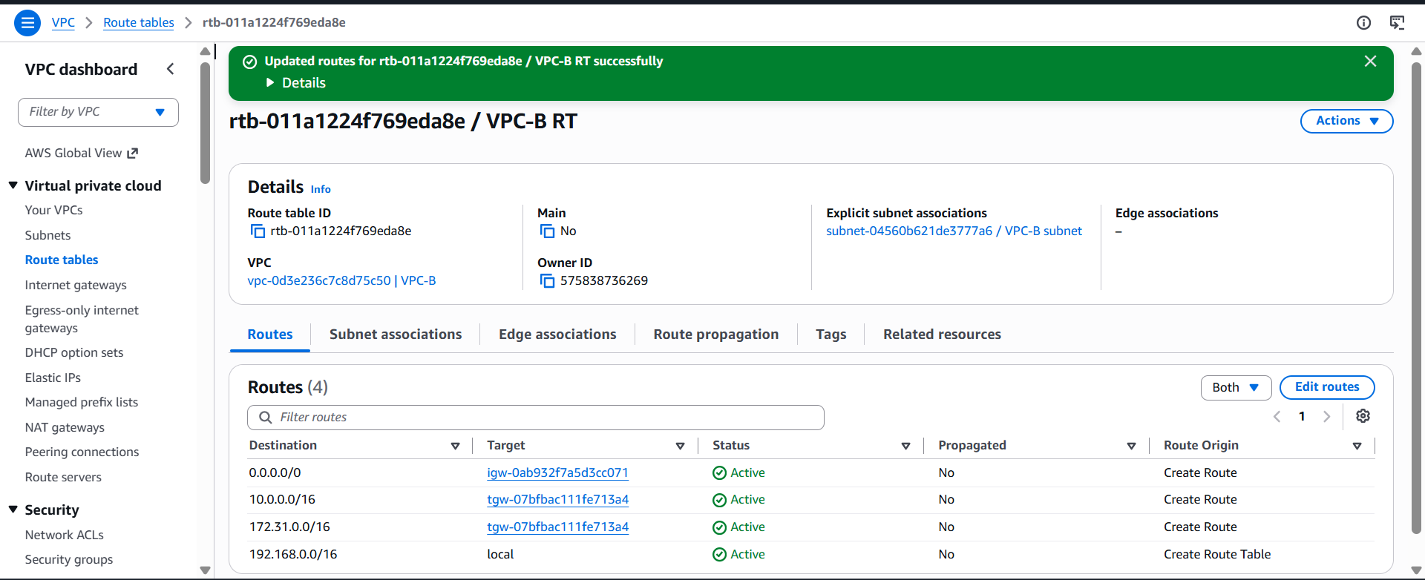
Route Table for the Default VPC
Keep:
- ✅ 172.31.0.0/16 → Local
- ✅ 0.0.0.0/0 → Internet Gateway
Add:
Destination | Target
10.0.0.0/16 | Transit Gateway
192.168.0.0/16 | Transit Gateway
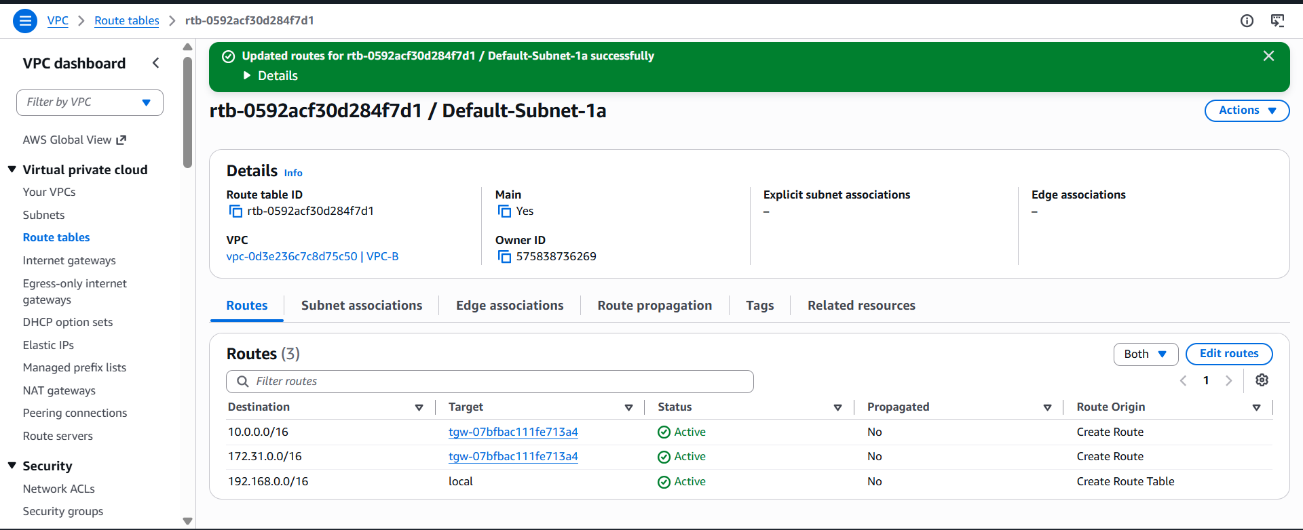
Open EC2 Dashboard
- Sign in to the AWS Management Console.
- Go to EC2.
- Click Instances.
- Click Launch instances.
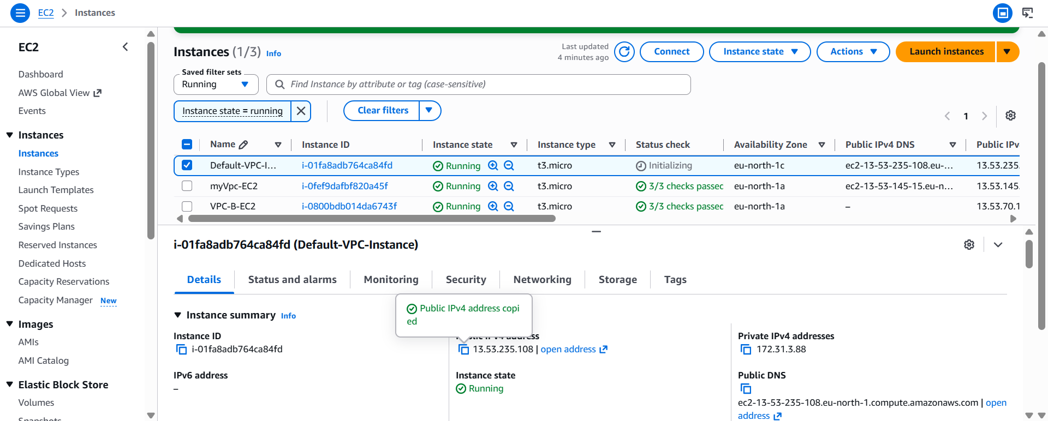
Verified the connectivity
Now SSH into your Default-VPC-Instance and run:
ping 10.0.1.231
or from myVpc-Instance:
ping 172.31.3.88
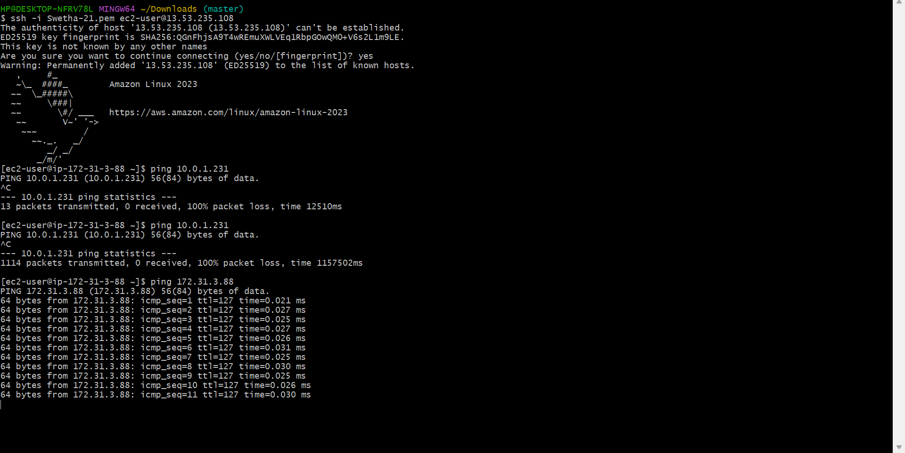
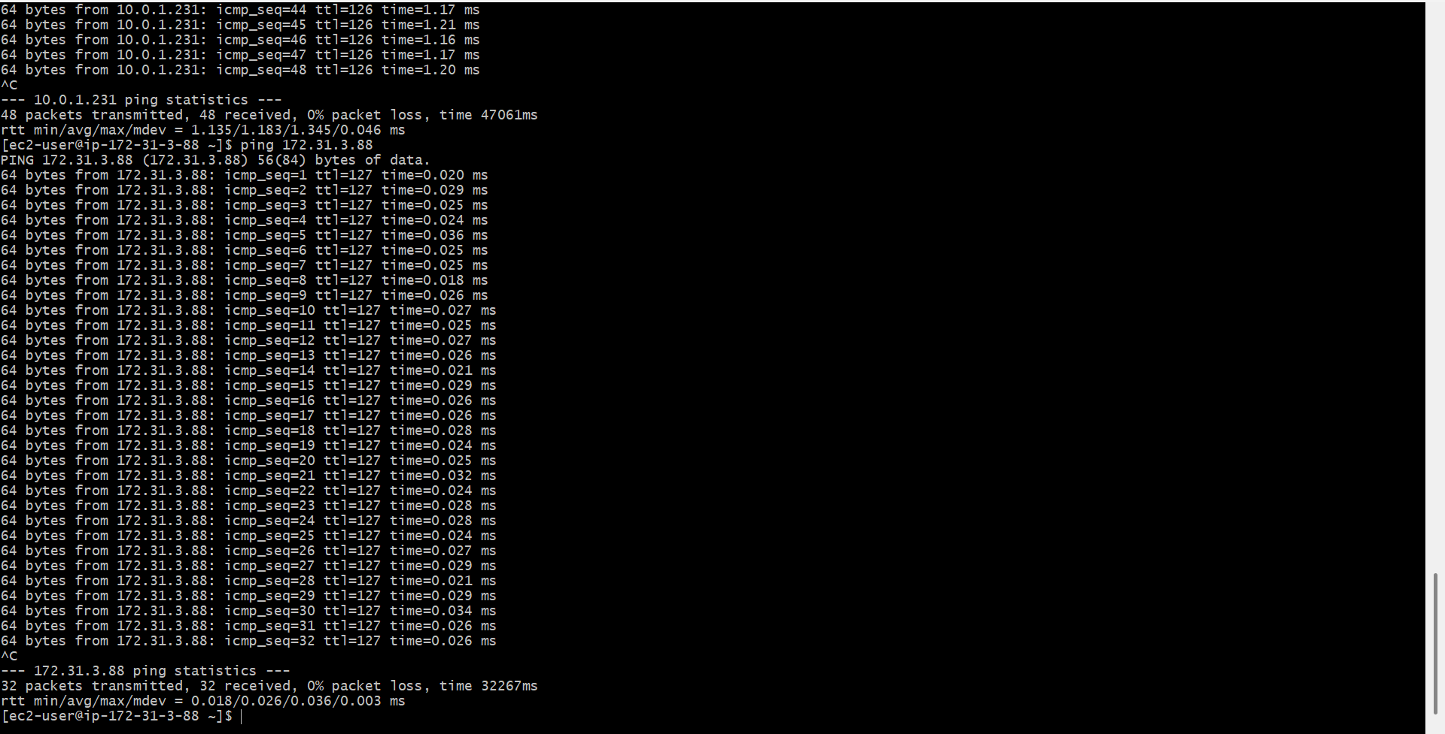
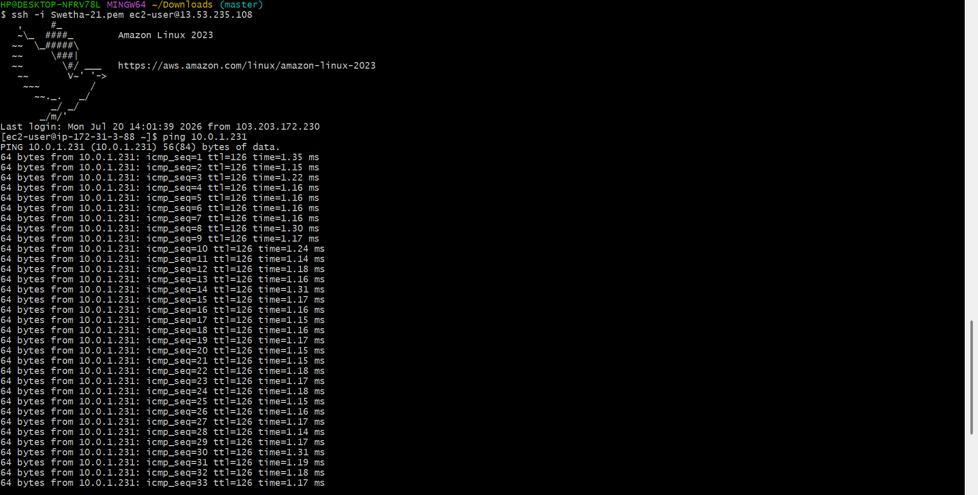
Set up a VPC Endpoint.
Open the VPC Console
- Sign in to the AWS Management Console.
- Go to VPC.
- In the left menu, click Endpoints.
- Click Create endpoint.
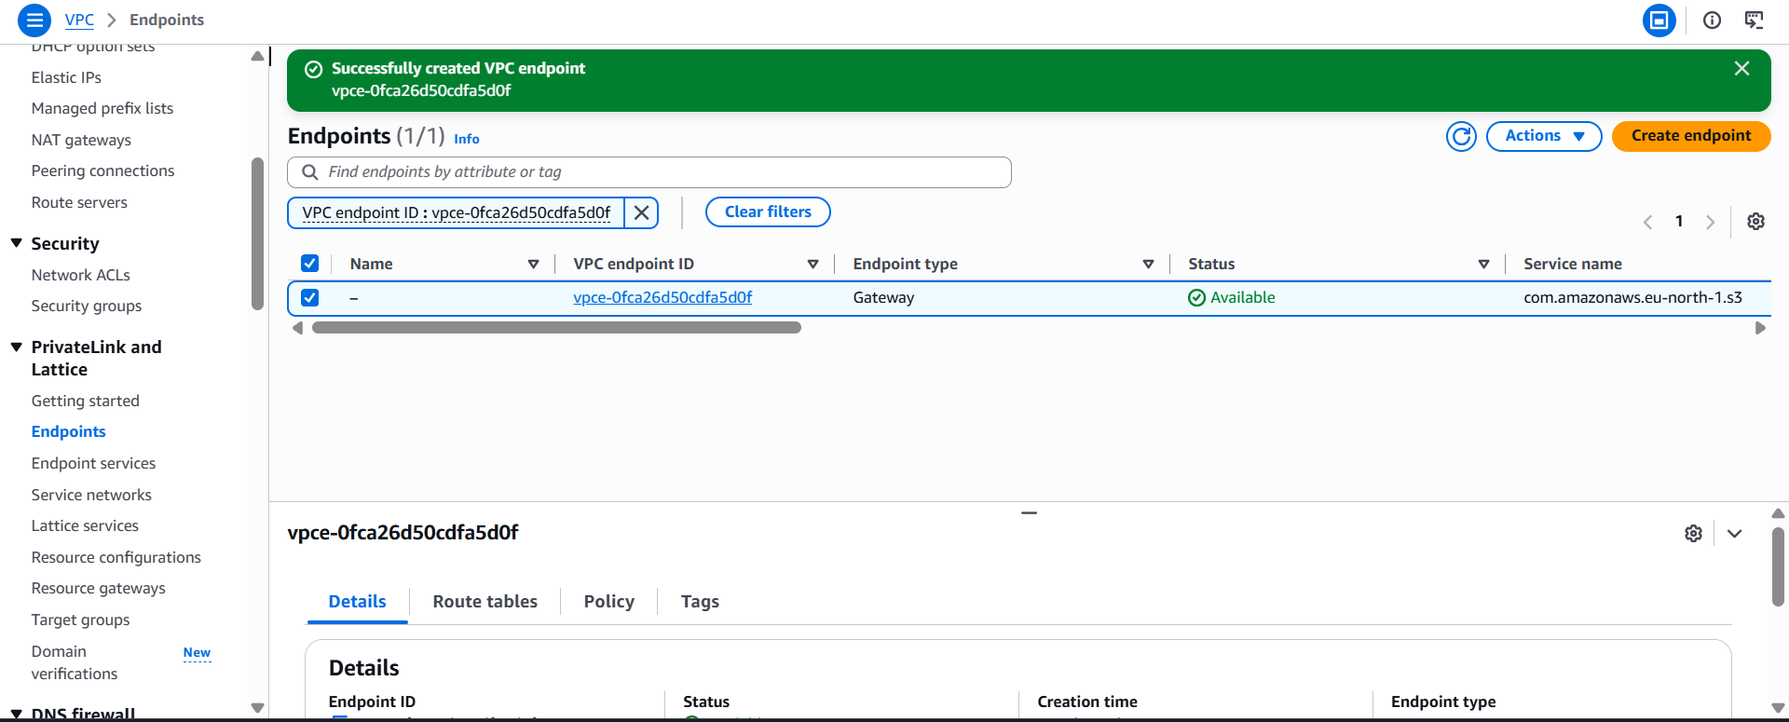
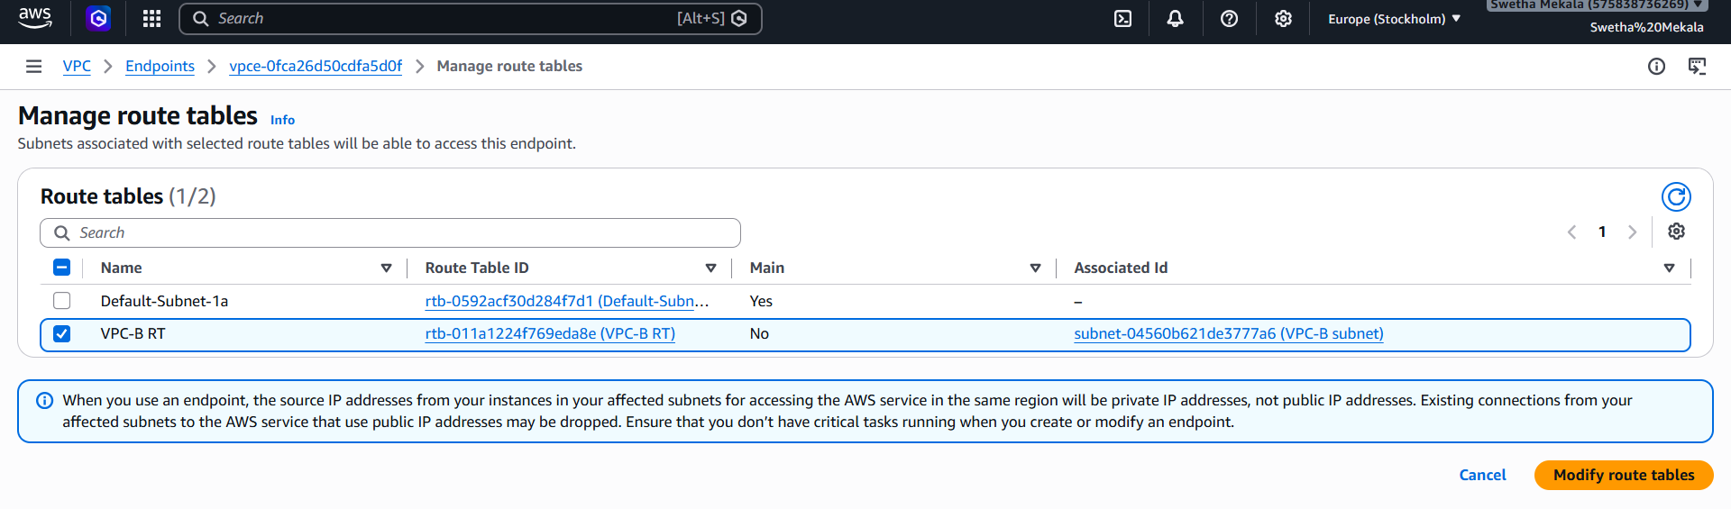
Connected to the EC2 instance using SSH:
ssh -i Swetha-21.pem ec2-user@13.61.183.74
Verified S3 access:
aws s3 ls
Output:
2026-07-19 04:04:38 my-vpc-flowlogs-2026
